Task 2 - Firewall Configuration
1.Install UFW on your Linux system (if not already installed) and enable it, then verify its status using the appropriate commands.
Step 1:- Install UFW by running:
- sudo apt update
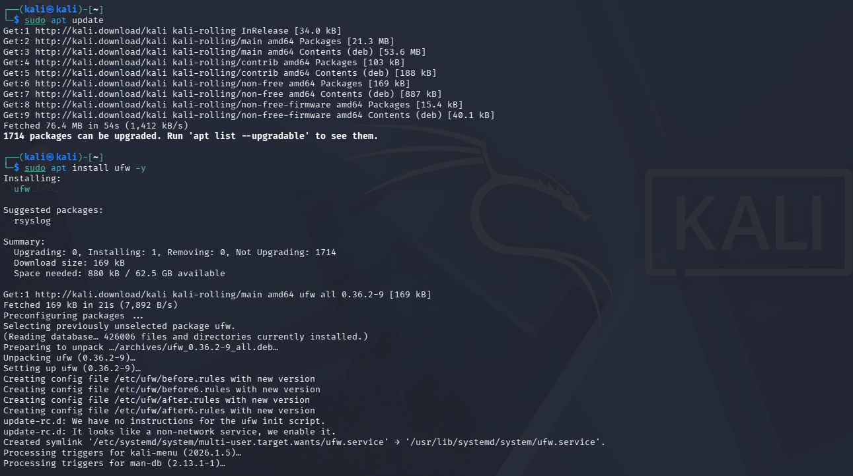
- sudo apt install ufw -y

Step 2: Enable UFW and Verify Its Status
After installing UFW, I enabled the firewall using the following command:
sudo ufw enable
I then verified that the firewall was running by checking its status.
sudo ufw status
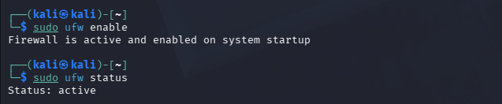
2.Allow incoming SSH (port 22) and HTTP (port 80) traffic using UFW. Then list all current firewall rules.
Step 1: Allow SSH and HTTP Traffic
To allow remote administration and web traffic, I added firewall rules for SSH (Port 22) and HTTP (Port 80).
Commands:
sudo ufw allow 22/tcp
sudo ufw allow 80/tcp
After adding the rules, I displayed all configured firewall rules using:
sudo ufw status numbered
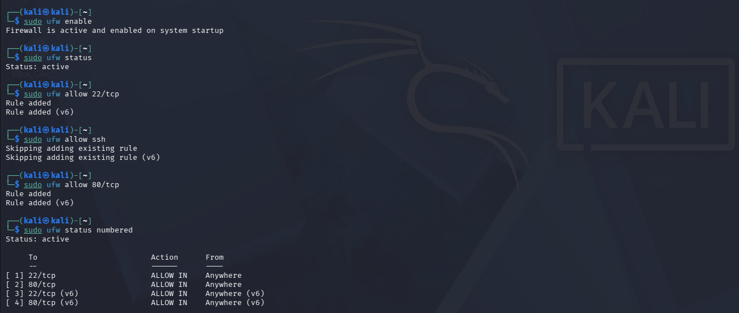
Step 1: Block Telnet (Port 23)
To improve system security, I blocked incoming Telnet traffic by creating a firewall rule that denies access to TCP port 23.
Command: sudo ufw deny 23/tcp
After adding the rule, I verified the firewall configuration using:
sudo ufw status numbered
The output confirmed that incoming Telnet traffic on port 23 was denied.
